Lab - Researching Network Collaboration Tools (Instructor Version)

**Instructor Note**: Red font color or Gray highlights indicate text that appears in the instructor copy only.

1. Objectives

Part 1: Use Collaboration Tools

* Identify current awareness of collaboration tools.
* Identify key reasons for using collaboration tools.

Part 2: Share Documents with Google Drive

Part 3: Explore Conferencing and Web Meetings

Part 4: Create Wiki Pages

1. Background / Scenario

Network collaboration tools give people the opportunity to work together efficiently and productively without the constraints of location or time zone. Collaborative tool types include document sharing, web meetings, and wikis.

In Part 1, you will identify collaboration tools that you currently use. You will also research some popular collaborative tools used today. In Part 2, you will work with Google Drive. In Part 3, you will investigate Conferencing and Web meeting tools and, in Part 4, you will work with wikis.

**Instructor Note**: This lab may be assigned as homework.

1. Required Resources

Device with Internet access

1. Use Collaboration Tools
   1. List some collaboration tools that you currently use today.

____________________________________________________________________________________

____________________________________________________________________________________

Answers will vary but could include: Google Drive, Cisco Webex, Citrix Go to Meeting, Confluence Wiki.

* 1. List some reasons for using collaboration tools.

____________________________________________________________________________________

____________________________________________________________________________________

Answers will vary but could include: centralization, less email, reduced travel and less environmental impact.

1. Share Documents with Google Drive

In Part 2, you will explore the document sharing functions by using Google Drive to set up document sharing. Google Drive, formally Google Docs, is a web-based office suite and data storage service that allows users to create and edit documents online while collaborating in real-time with other users. Google Drive provides 5 GB of storage with every free Google account. You can purchase additional storage, if needed.

* 1. Create a Google account.

To use any of Google’s services, you must first create a Google account. This account can be used with any of Google’s services, including Gmail.

* + 1. Browse to [www.google.com](http://www.google.com) and click **Sign in** (located at the top-right corner of the web page).

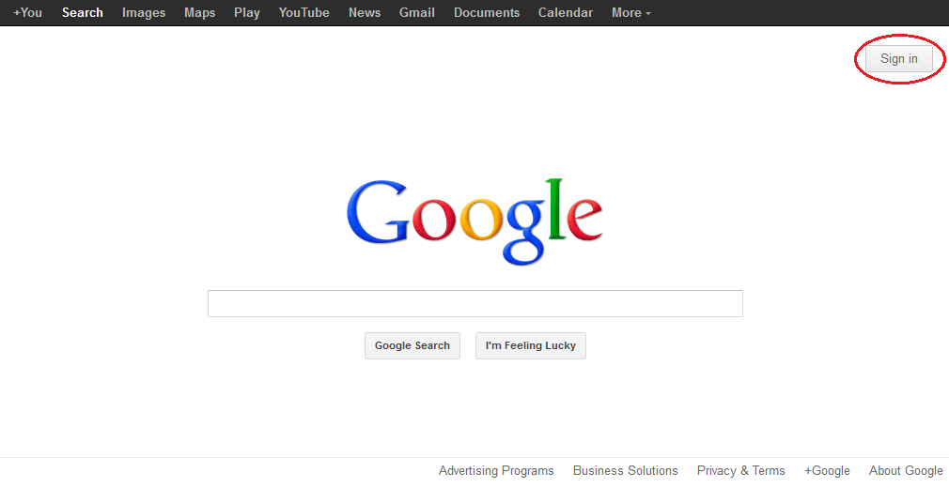

* + 1. On the Google Accounts web page, if you already have a Google account, you can sign in now; otherwise, click **SIGN UP**.

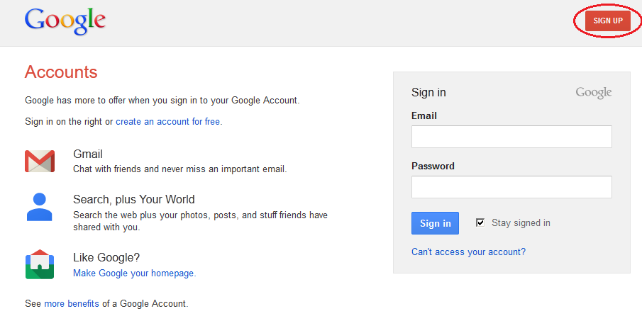

* + 1. On the Create a new Google Account web page, fill out the form to the right. The name you enter in the **Choose your username** field becomes the account name. It is not necessary to supply your mobile phone or current email address. You must agree to the Google Terms of Service and Privacy Policy before clicking **Next step**.

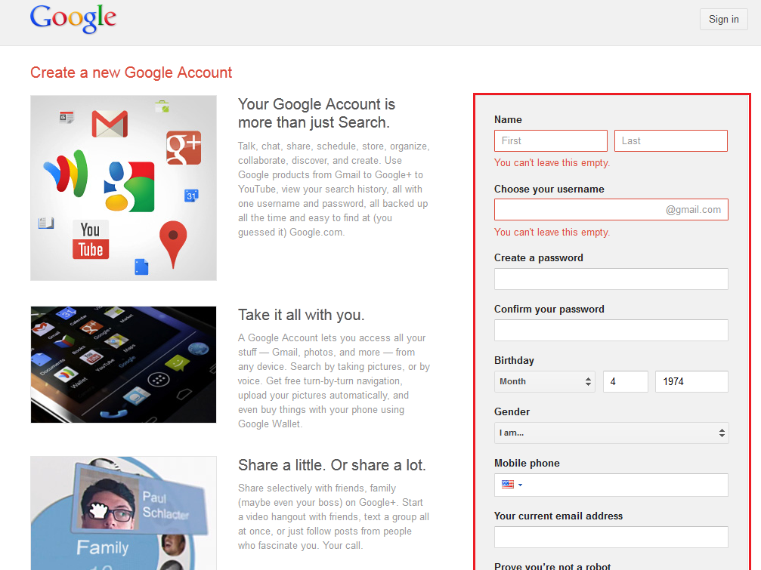

* + 1. The next web page allows you to add a profile photo if you would like. Click **Next Step** to complete the account creation process.
  1. Create a new document.
     1. Sign in to Google using the access credentials you created in Step 1. Type **http://drive.google.com** in your browser and press Enter. This navigates you to Google Drive.

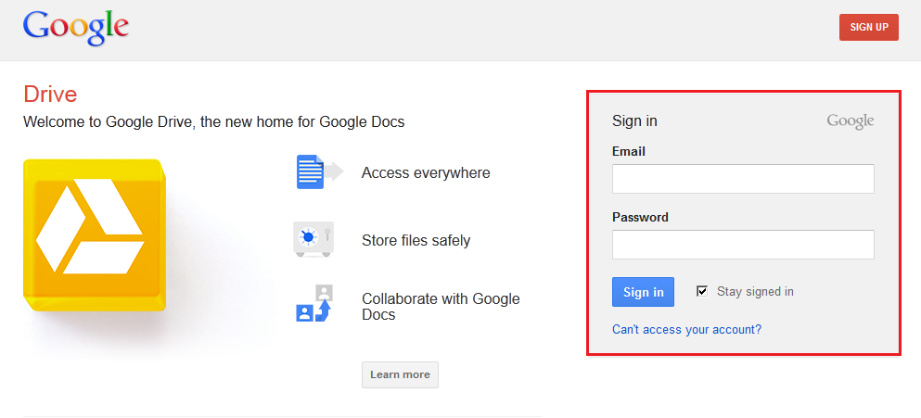

* + 1. Click the **CREATE** button to display a drop-down menu that allows you to select the type of document to create. Choose **Document**.

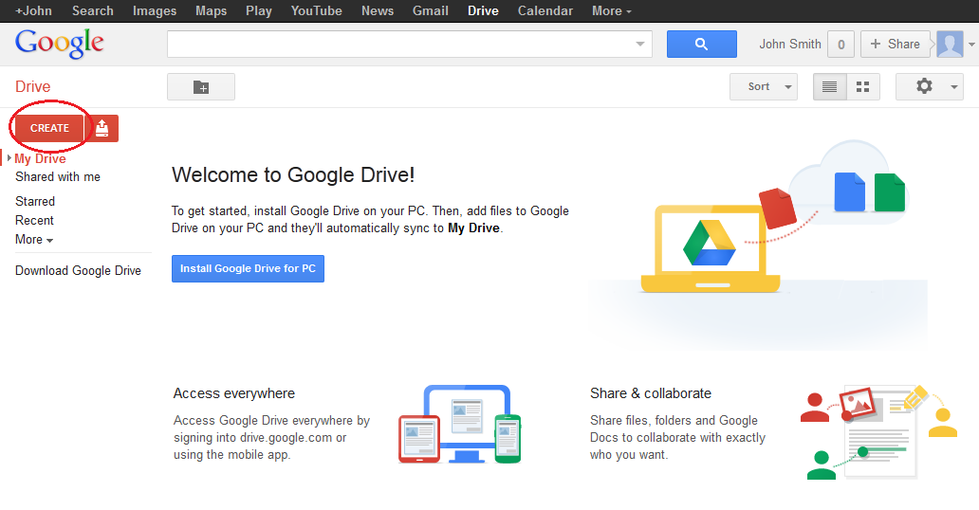

The new document displays. Many of the functions of the Google editor work similarly to Microsoft Word.

* 1. Share a Google document.
     1. After the blank Google document opens, you can share it with others by clicking the **Share** button (at the top-right corner of the web page).

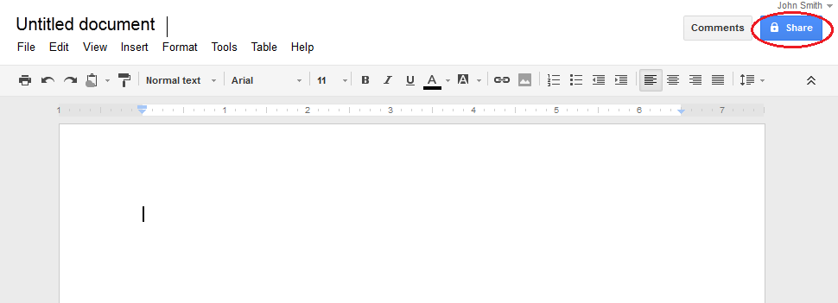

* + 1. Name your new document, then click the **Save** button.

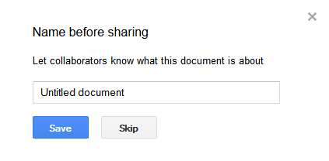

* + 1. Here on the Sharing settings web page, in the **Add people** text field, you can enter Google email names, email addresses, or groups with whom to share this document.

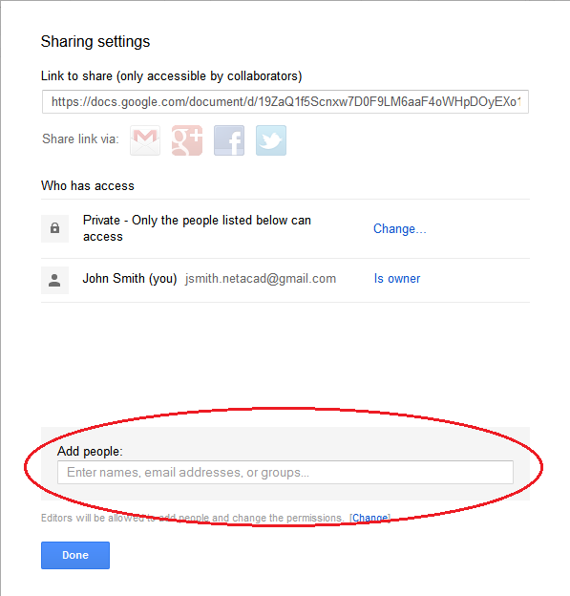

* + 1. As soon as you start entering information into the **Add people** box, the box provides more options. The **Can edit** drop-down menu allows you to choose the document privileges (Can edit, Can comment, Can view) for the people you add. You can also specify how to notify these people of this document (**Send a copy to myself** or **Paste the item itself into the email**). Click **Share & save**.

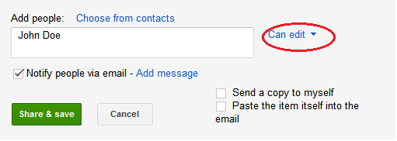

* + 1. Click the **Done** button. This will navigate you back to the open document.
    2. All users with share privileges can view this document at the same time. Users with edit privileges can edit this document while others view it.
    3. If the document is being viewed by someone while you are in it, you can see who they are by clicking the **other viewer(s)** drop-down menu (in the upper-right corner of the document).

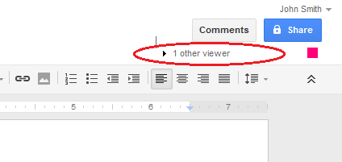

* 1. Close a Google document.

To close a Google document, move your cursor to the document name at the top of the screen and a left arrow will appear to the left of the name. Click that arrow to return to your Google Drive home page. The document is automatically saved.

The new document will appear at the top of your documents list under My Drive.

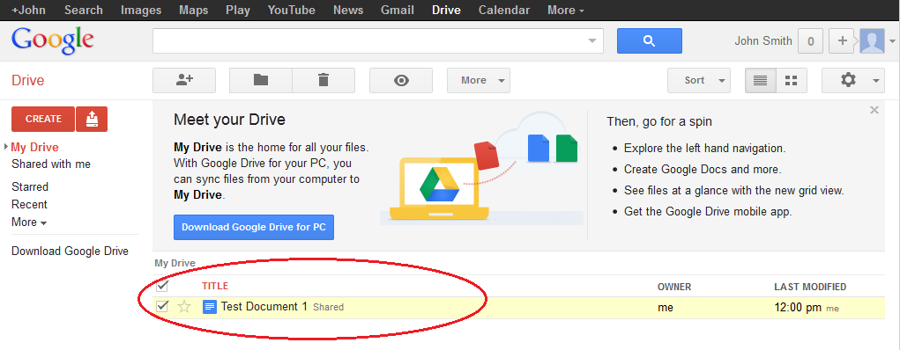

* 1. Additional Information

Google has developed apps for PCs and Smart phones. For more information about Google Drive, go to <http://drive.google.com>. YouTube is also a viable source of Google Drive tutorials.

1. Explore Conferencing and Web Meetings

Web meetings combine file and presentation sharing with voice, video, and desktop sharing. Cisco WebEx Meeting Center is one of the leading web meeting products available today.

In Part 3 of this lab, you will watch a video produced by Cisco that reviews the features contained within WebEx Meeting Center. The video is located on YouTube at the following link: <http://www.youtube.com/watch?v=fyaWHEF_aWg>

**Instructor Note**: For additional WebEx conferencing tools, you can register for a free WebEx Meeting Basics account at www.webex.com.

1. Create Wiki Pages

“Wiki” is a Hawaiian-language word that means fast. In networking terms, a wiki is a web-based collaboration tool that permits almost anyone to immediately post information, files, or graphics to a common site for other users to read and modify. A wiki provides access to a home page that has a search tool to assist you in locating the articles that interest you. A wiki can be installed for the Internet community or behind a corporate firewall for employee use. The user not only reads wiki contents, but also participates by creating content within a web browser.

Although many different wiki servers are available, the following common features have been formalized into every wiki:

* Any web browser can be used to view or edit pages or create new content.
* Edit and auto links are available to edit a page and automatically link pages. Text formatting is similar to creating an email.
* A search engine is used for quick content location.
* Access control can be set by the topic creator, defining who is permitted to edit content.
* A wiki is a grouping of web pages with different collaboration groups.

In this part of the lab, you will use the Google account that you created in Part 2 and create a wiki page in Google Sites.

* 1. Sign in to Google Sites.

Go to <http://sites.google.com> and sign in using the Google account that you created in Part 2 of this lab.

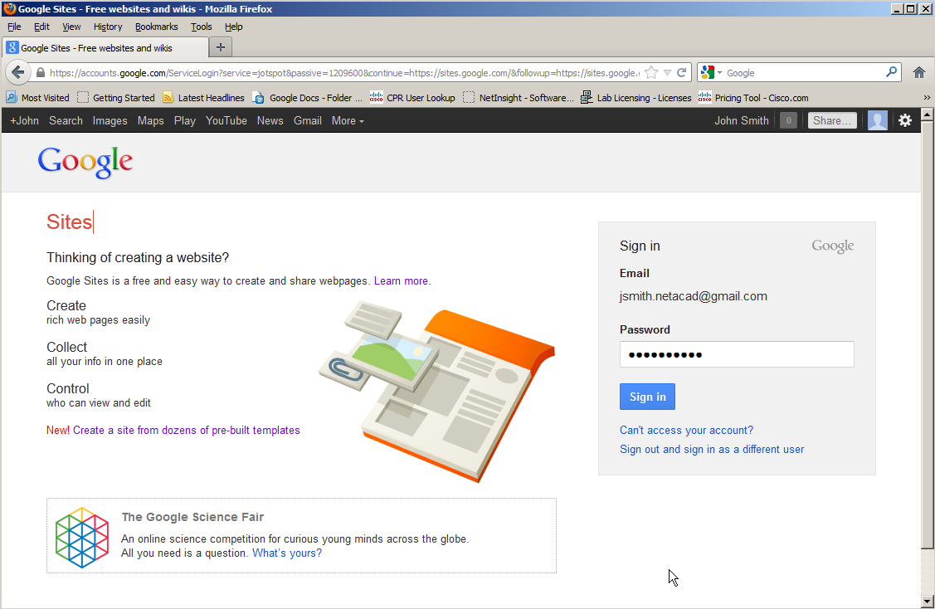

* 1. Click CREATE.

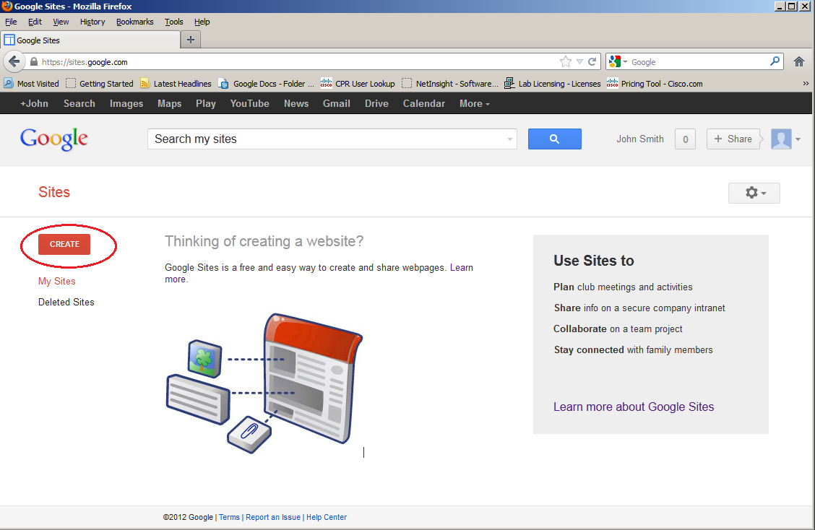

* 1. Name your new wiki site.

In the **Name your site** field, type in a name for your new wiki site. You will need to come up with a unique name for your site that has not been used by any other Google user. Google also requires that you enter the code (displayed at the bottom of the screen) to prevent automated scripts, called web robots, from creating multiple sites. After you have entered your site name, click the **CREATE** button. If someone has used your site name already, you are prompted to enter another name.

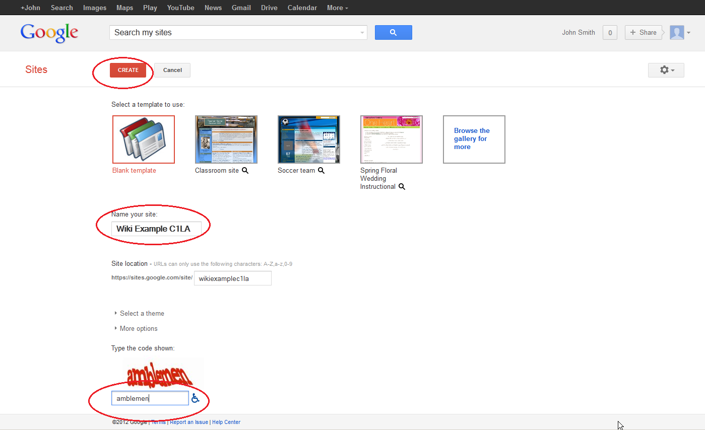

* 1. Edit the look of your new wiki site.
     1. Google has provided templates for you to change the look of your new wiki site. Click the **More** drop-down menu, and then click **Manage site**.

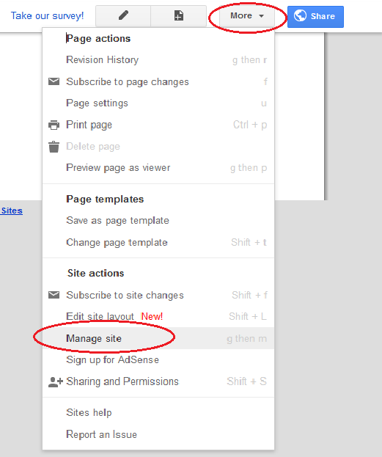

* + 1. Click **Themes** at the bottom of the left sidebar.

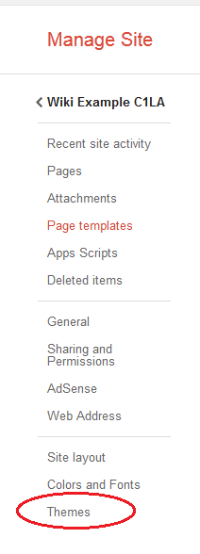

* + 1. Select a theme that appeals to you and click **SAVE**.

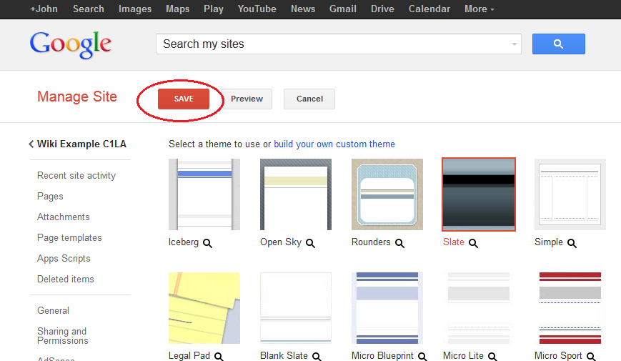

* + 1. After you have saved your theme selection, click your site name under **Manage Site**.

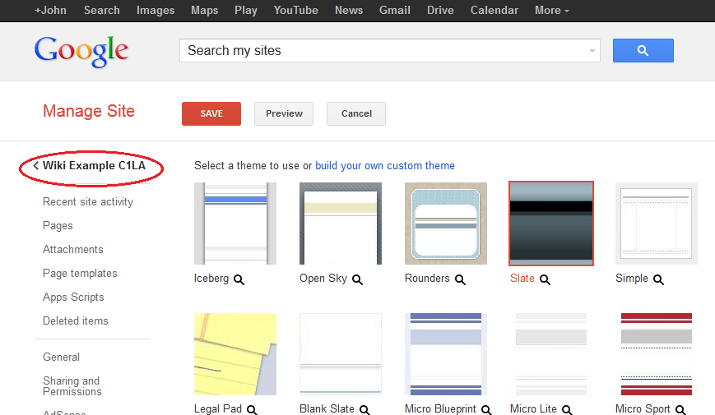

* 1. Update the Home page.
     1. The Home page is the first page that everyone sees when they come to your wiki site. You can edit the content of this page by clicking the edit button. From here, you can add text, pictures, or anything else to show on this page.

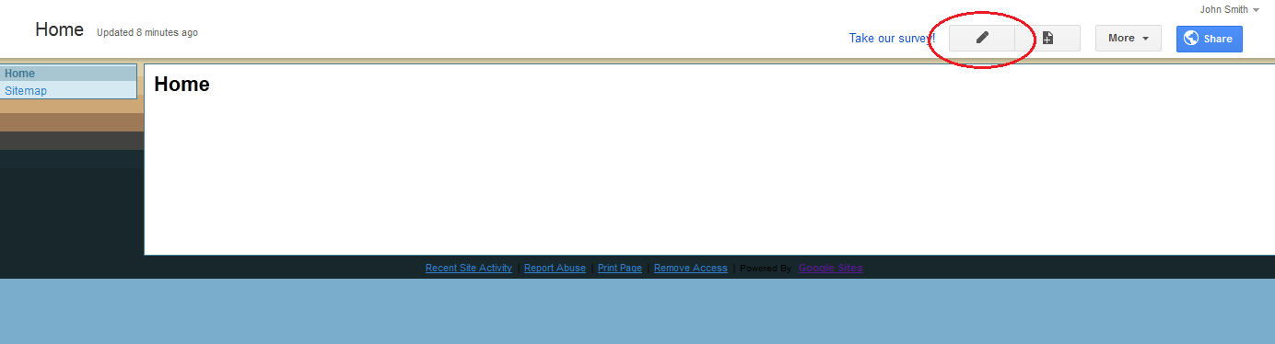

* + 1. Click **Save** after you make your changes. This takes you out of page edit mode.

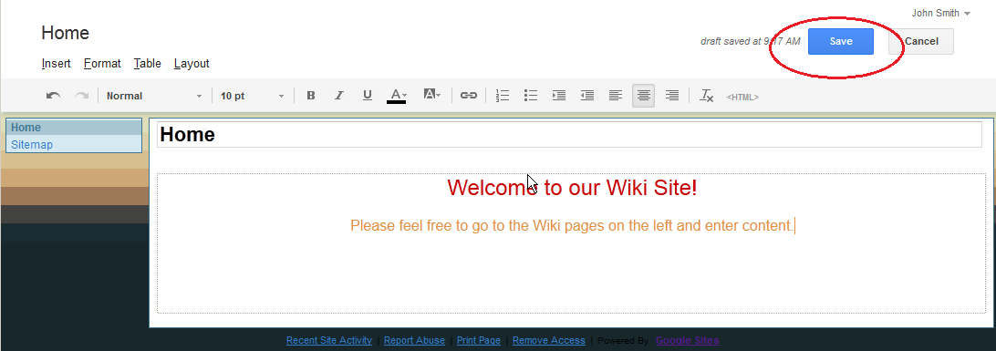

* 1. Create a wiki page.
     1. To create a new page that you and your visitors can use to make posts, click the new page icon.

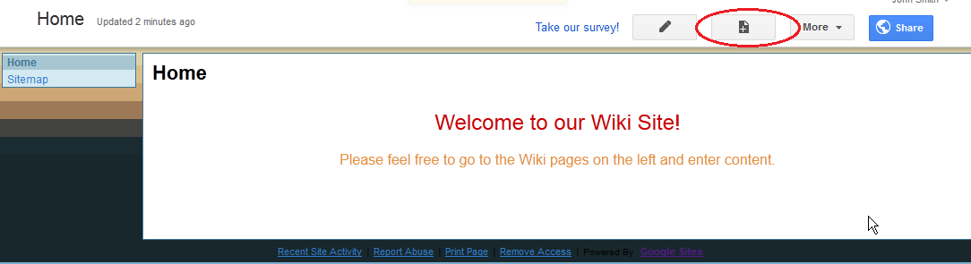

* + 1. In the **Name your page** field, enter a page name. In the example below, the name Routers is used as the topic for this page.

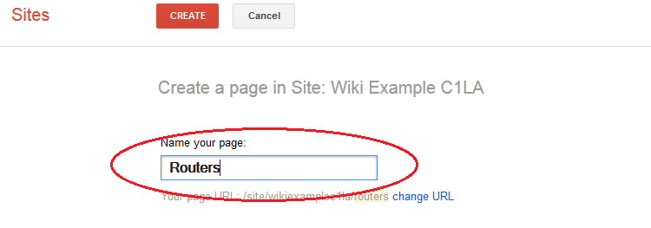

* + 1. Click the **Web Page** drop-down menu and select **Announcements**. Google uses this term to indicate a wiki page.

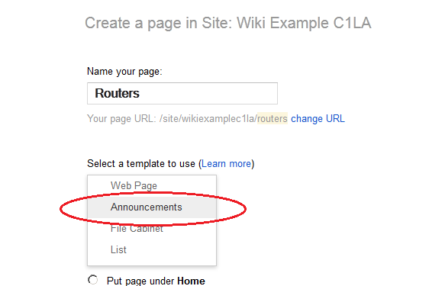

* + 1. Click **CREATE** to create your new wiki page.

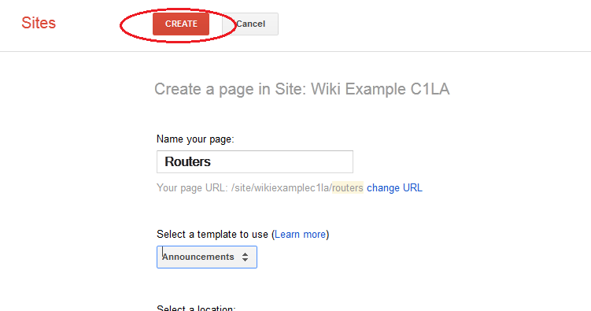

* + 1. Your new wiki page, called Routers, displays and has a **New post** menu option that allows information to be added to the page. (Notice that the left sidebar has a new link to allow your site visitors access to this page.)

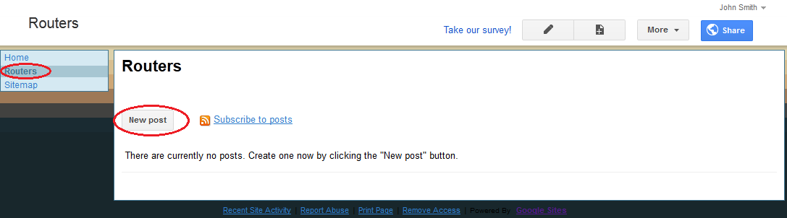

* 1. Share your web site.

A wiki site is not really a wiki site unless other people can contribute. There are a number of ways to share your new site. In this example, we will show you how to share your site to designated people who have Gmail accounts.

* + 1. On your wiki site, click **Share**.

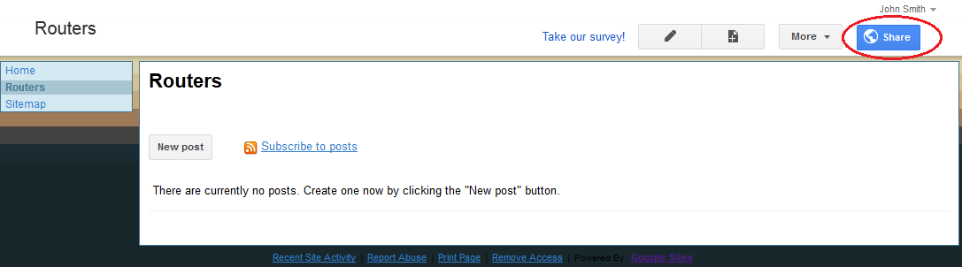

* + 1. Add a name, email address, or group who you grant access to this site.

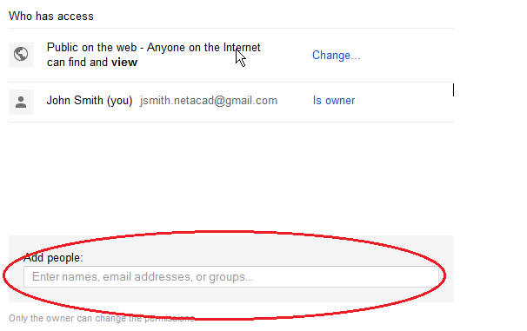

* + 1. As soon as you start entering information into the **Add people** box, the box provides more options. The **Can edit** drop-down menu allows you to choose the document privileges (Can edit, Can comment, Can view) for the people you add. You can also specify how to notify these people of this document (**Send a copy to myself** or **Paste the item itself into the email**). Click **Share & save**.

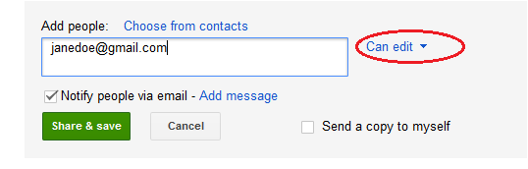

* + 1. Click **Share & save** to save **your sharing settings**.

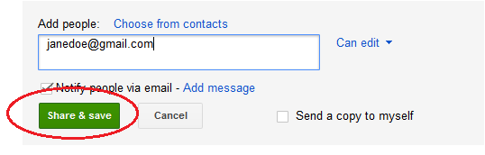

* + 1. The **Manage Site** page displays the people who have access to your site. Click your site name to return to your home page.

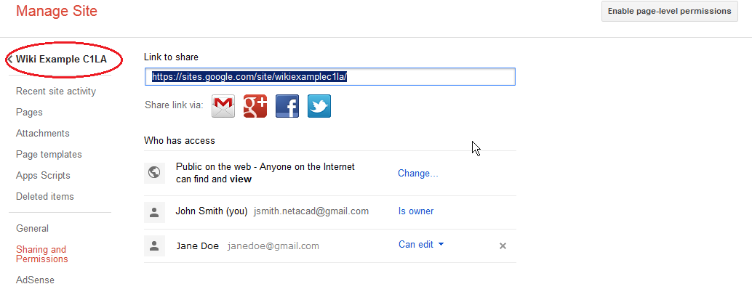

* 1. Provide the URL of your site.

You can provide your URL to your new site by adding your site name to the end of the Google site URL, as shown here: http://sites.google.com/site/(sitename).

* 1. Find additional information.

You can find a quick overview of how a wiki works at <http://www.youtube.com/watch?v=-dnL00TdmLY>.

Other examples of wikis and their web sites include:

* Wikipedia — <http://www.wikipedia.org/>
* Atlassian Confluence (a popular business wiki) — <http://www.atlassian.com/software/confluence/>
* Wikispaces (another free wiki) — <http://www.wikispaces.com/>

1. Reflection
   1. Can you think of other collaboration tools used in the business world today?

_______________________________________________________________________________________

Answers will vary.

* 1. What collaboration tools do you see as useful to a network administrator?

_______________________________________________________________________________________

Answers will vary.